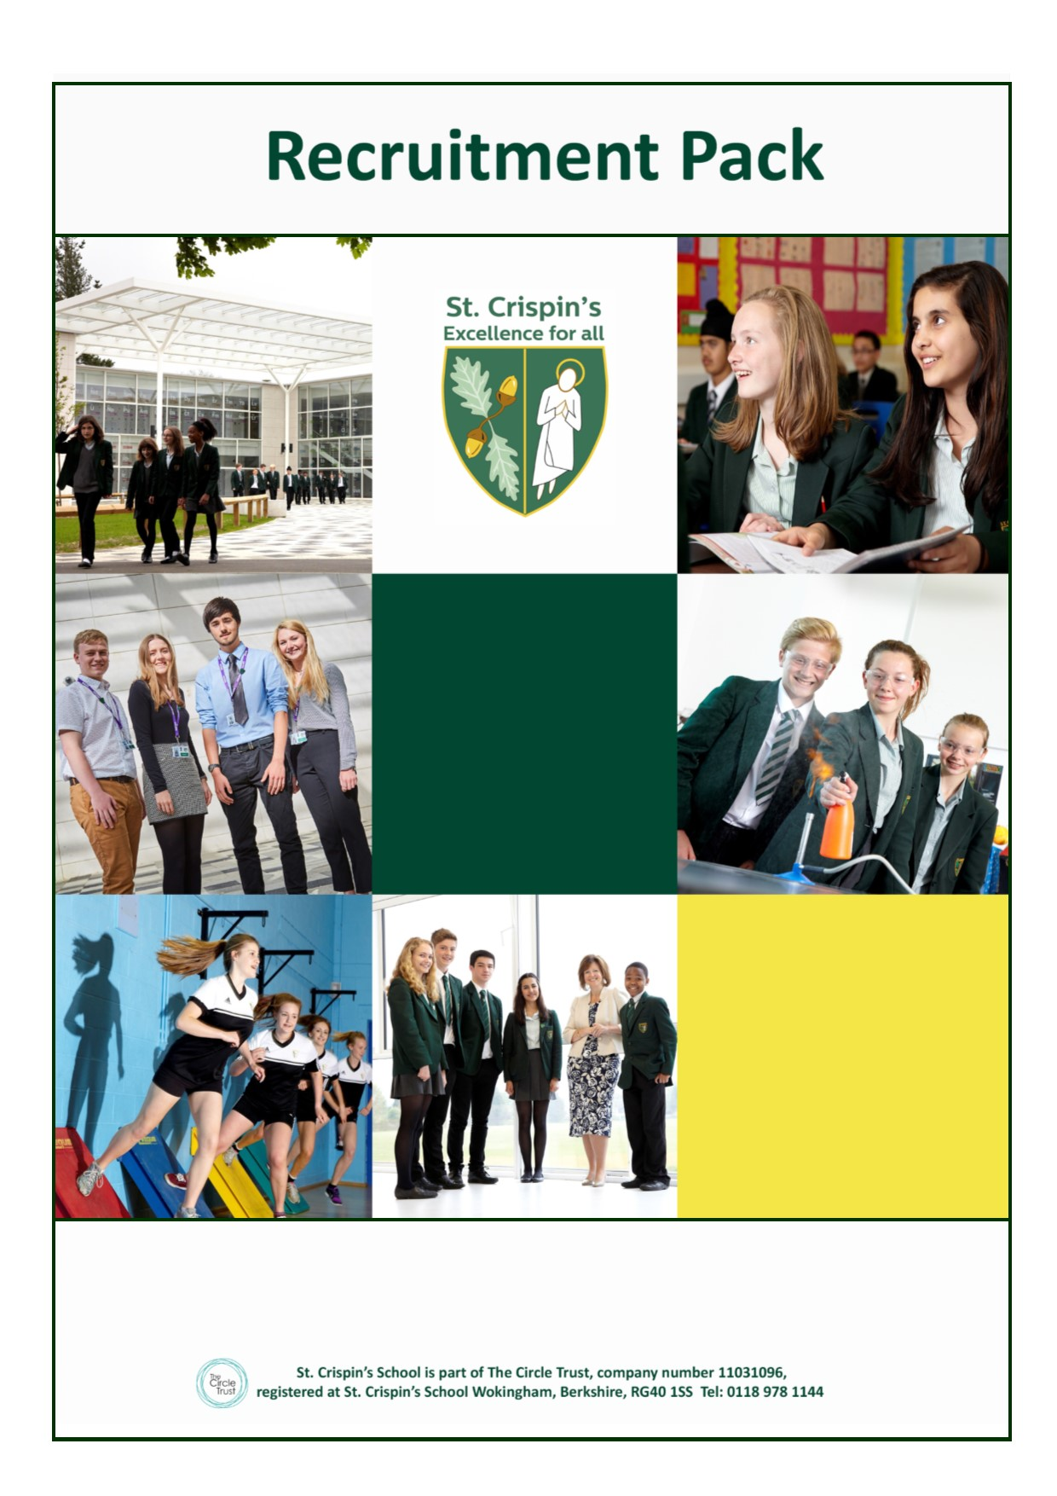
Receptionist & Administrative Assistant
Receptionist & Administrative Assistant

St Crispin’s School
Headteacher:
Ginny Rhodes
NOR 1130, 11-18
Mixed Comprehensive London Road, Wokingham, Berkshire RG40 1SS
Tel: 0118 978 1144
Fax: 0118 979 5224

www.crispins.co.uk

22.5 hours per week (Mon-Fri 12.15-16.45) - Term time only + 5 INSET days. £8.70 / hour

St. Crispin’s School is a happy and oversubscribed 11-18 mixed comprehensive school. Our school motto is “Excellence for All” and this encapsulates our commitment to do the very best for both students and staff. Standards within the school are high.

We have a rare opportunity to join our successful and friendly support staff team who enjoy an excellent reputation both within and beyond the school. We are seeking a flexible, team player who thrives in a fast-paced environment where no two days are ever the same!

The successful applicant will play a key role as the first point of contact for all visitors to the school reception. You will be a warm, friendly problem-solver with great attention to detail, who loves taking ownership. You will also have excellent administrative, IT, and interpersonal skills.
The role combines a stimulating mix of administration and interaction with a wide range of visitors, in addition to students. A willingness to administer first aid would be an advantage. Full training will be provided.
Further details and an application form are available from the school website under Vacancies.
Closing date: 9am 16th April 2018.
Please submit your application to Mel Knight knightm@crispins.co.uk
We aim to contact shortlisted candidates within 1 week of the closing date.

This school is committed to safeguarding and promoting the welfare of children and young people and expects all staff and volunteers to share this commitment. Appointments are subject to enhanced DBS clearance and satisfactory employment references.

Job Description

Salary The Circle Trust’s Support Staff Pay Scale Grade 3

Terms and conditions

Contract: Term time + 5 INSET days
Hours per week: 22.5 hours
Hours of work: Monday to Friday, 12.15–16.45

Aim and main purpose of the job

To support the smooth and efficient running of the school’s administration to ensure the continued delivery of a high quality teaching and learning environment for pupils.

Day-to-day running of the visitor and student reception acting as a key administrative contact point for pupils.

General Accountabilities

1. Undertake reception duties, answering general telephone and personal enquiries and signing in visitors.

2. Provide general clerical/administrative support including: - photocopying, filing, e-mailing, sorting and distributing mail etc.

3. Manage correspondence and prepare more complex documents/forms.

4. Undertake word processing, data entry and other ICT based tasks e.g. operate M.S Office software and use the Internet.

5. Provide administrative assistance to senior staff as required.

6. Manage and run computerised reports, provide lists/information/data as required.

7. Maintain manual and computer-based records and management information systems e.g. SIMS, maintain and collate pupil records.

8. Provide general advice and guidance to pupils, staff and others.

9. Review students reporting to reception who are feeling unwell, manage the medical room and have a willingness to administer first aid if appropriate.

10. Liaise with parents where required.

11. Comply with policies and procedures relating to child protection, health, safety, welfare, security, confidentiality and data protection, reporting any concerns to the appropriate person.

12. Contribute to the overall aims and targets of the school, appreciate and support the roles of other members of the school work team and attend and participate in relevant meetings as required.

13. To follow statutory guidance and school policies including child protection and safeguarding.

14. Any other duties reasonably required by the Headteacher.
Details of Line Management

This post is line managed by the Business Manager
Notes

Whilst every effort has been made to explain the accountabilities of this post, each individual task undertaken may not be identified.

This job description is current, but following consultation with you, may be changed by the Headteacher to reflect or anticipate changes in the job, which are commensurate with the salary and job title.

